# Assignments-2 on gdb

## Name:- ATRIJ ROY

## Roll no:- 002311001086

## Class:- IT UG2 A3

1. Consider the program in folder assign2.
   1. Put a breakpoint in the 1st executable line of the innermost loop.

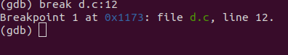

* 1. If you run and continue ,how many times it is supposed to stop at breakpoint 1?

10*200*3000=6000000 times

* 1. How will you continue so that it stops at the 1000th iteration of the innermost loop ?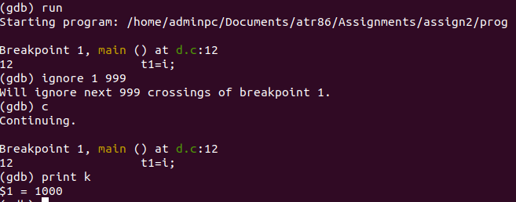
  2. How you can condition your breakpoint , so that the loop stops at every 1000th iteration of innermost loop ?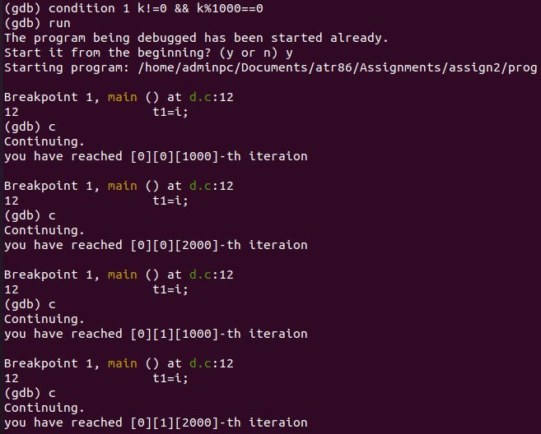
  3. Put a breakpoint in the 1st line of the outermost loop.

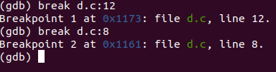

* 1. Disable breakpoint “1”

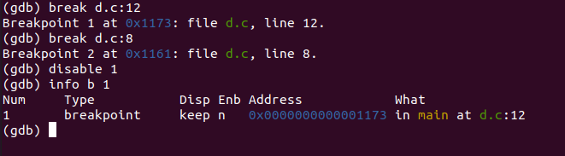

* 1. Add a command to breakpoint 2 so that it prints the value of “i” at each hit.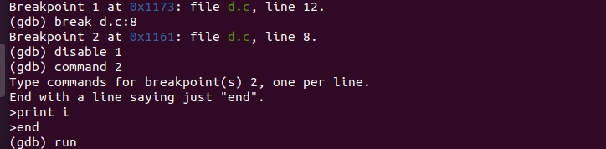

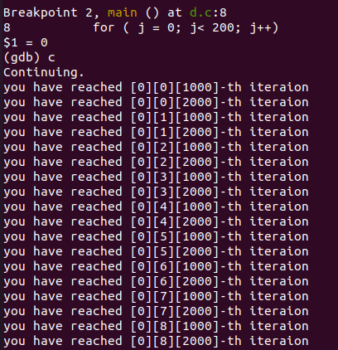

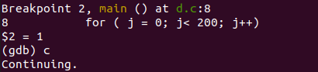

* 1. Delete breakpoint 2.

